1. 
2. Now, we know that Docker Repository is a set of different versions of images and we can create different versions using image’s tag attribute.
3. We can assign different tags to a same Docker image which is not a good practice.
4. Now you can create your custom images too.
5. But if you have created an awesome image and you want to share it with others.
6. Of course you have email, FTP or some other services. But of course you should use registry to share your work with others.
7. The most popular registry is **Docker Hub**.
8. You can create repositories on Docker Hub and can share those repositories with others.
9. **Registry** = A set of named Docker Images.
10. 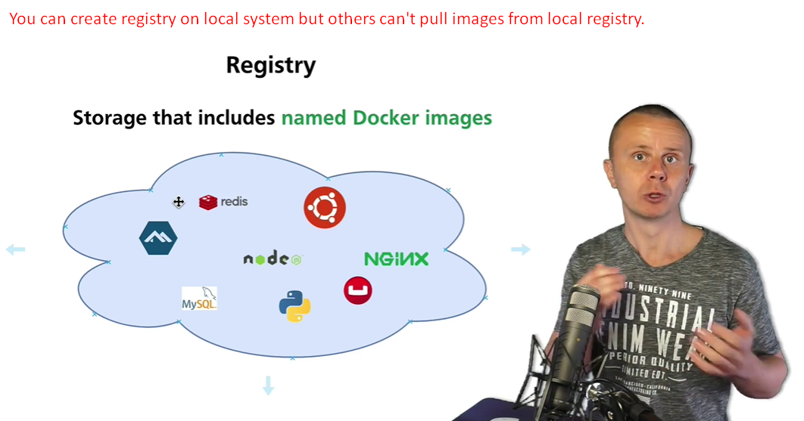  
    If you create registry on local computer, then no one can pull those images on your local registry.
11. So you want to share your images, you could use public registry such as Docker Hub.
12. 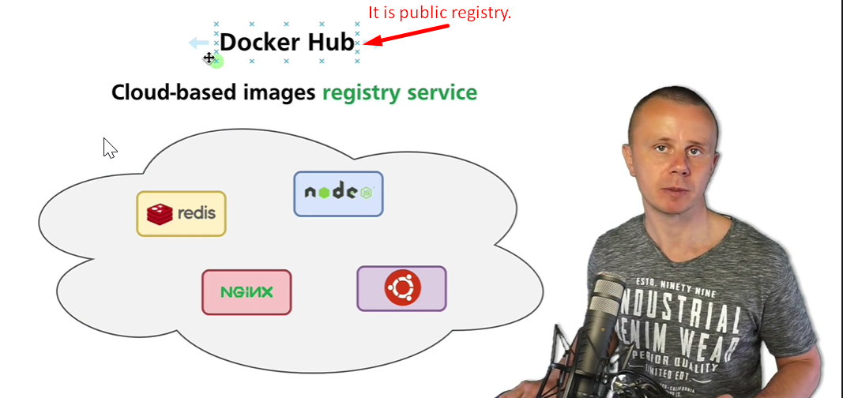
13. On Docker Hub, we can create public repository or private repository which is available for company members.
14. Let’s us to go the Docker Hub and see how it is structured.
15.   
    Such as redis is official image as provided by the company.
16. 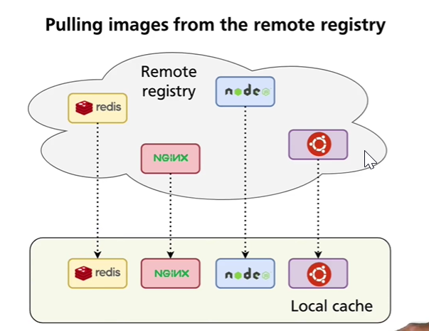

So,

Docker Hub is a registry where Docker images are hosted to be used by others.

Docker Hub is like Git Hub.